Exploratory Data Analysis
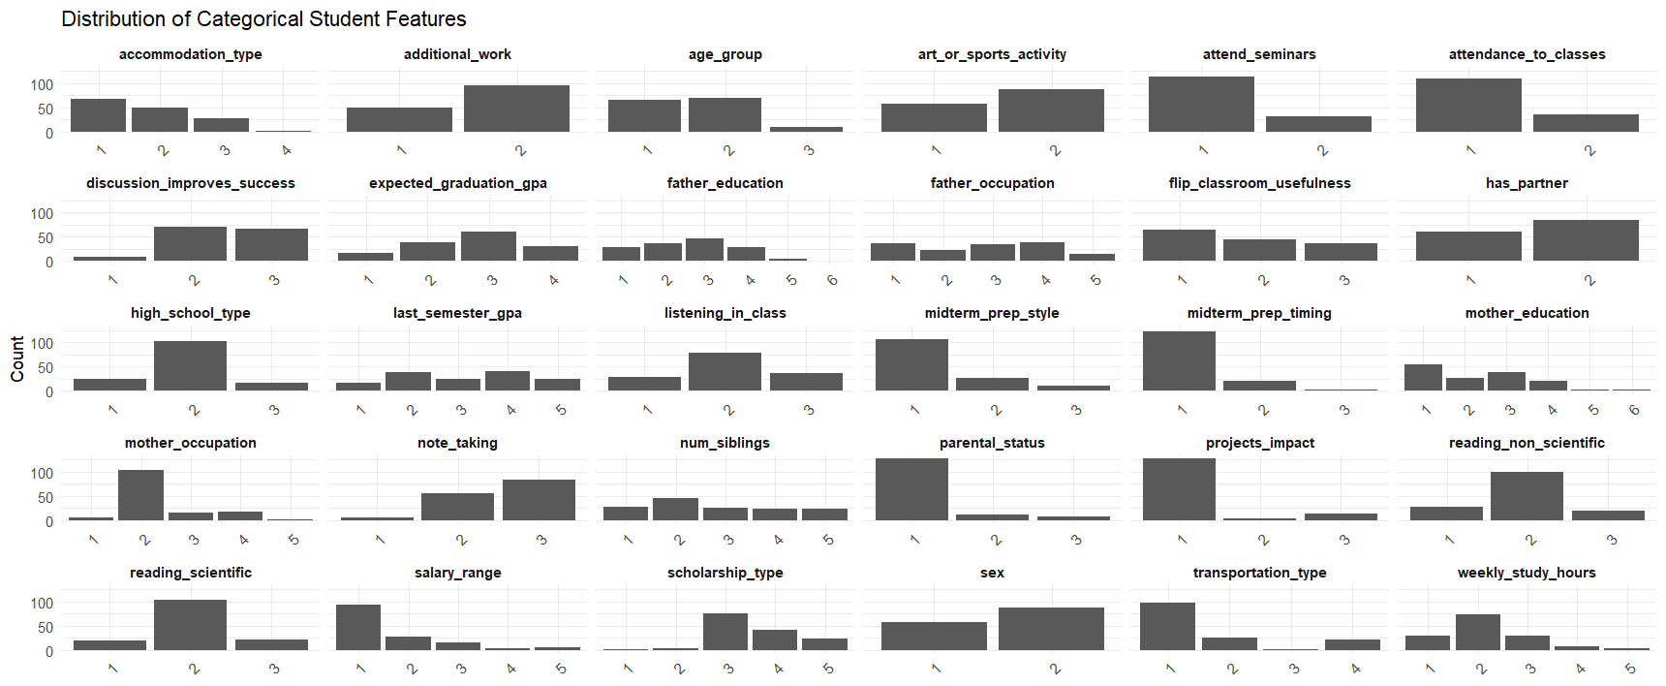
I chose “Higher Education Students Performance Evaluation” as my dataset. I was interested in this topic as I am pursuing higher education, and I thought the data was insightful. Upon looking at the dataset, I realized I had to clean up the columns in a few ways. First, I had to name the columns because they were just x1-30. By taking the names from the website, I could understand the data a little more. Additionally, since all of the predictors were categorical or ordinal, I converted them to factors before running any tests. Ordinal encoding preserves the natural ordering of variables such as GPA, study hours, and attendance, which is important for interpretability and model behavior. The output grade variable was converted from numeric codes (0–7) into an ordered categorical factor representing letter grades from Fail to AA. To understand the data more, I wanted to look at the relationship of each variable in regards to grades. I plotted a distribution bar graph with each variable.
Figure 1: Distribution bar graph of all variables vs Grades
From this, salary range, scholarship type, and high school type are three variables that are interesting to me. I want to focus on the background rather than the individual student decisions. To continue to clean up the data, I distinguished these specific columns by adding a labels column in relation to their numeric assignment from the website. After doing this, I wanted to see their performance in school in relation to grades.
Figure 2 provided me more insights on the general makeup of these three variables. One key insight was that scholarship type showed the strongest variable with grades with students with higher scholarships have noticeably larger proportions of BA and AA and fewer Fail/DD grades. Furthermore, salary range appears to have a moderate association with grades, but it is not deterministic. Students from all income brackets achieve a range of outcomes. High school type has some influence, but its effect is weaker than scholarship status. This frames the rest of the models to help support this preliminary examination.
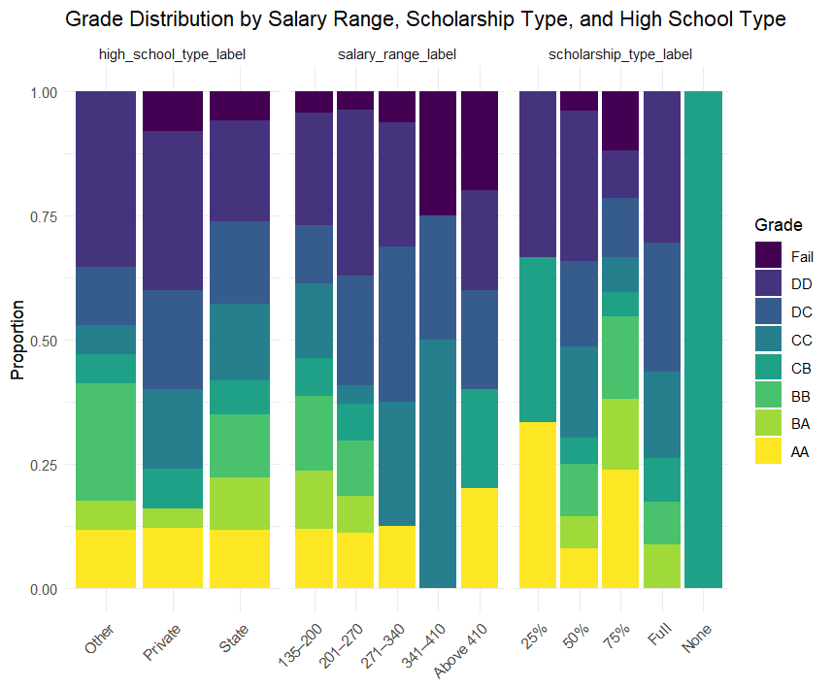
Figure 2: Grade Distribution of Salary, Scholarship type, and High school type

Model Development
To predict grade categories, I wanted to do Random Forest Classifier. This is because it handles categorical variables well and acts as a strong baseline for classification. I could have used the original numeric grade values, but it would be easier to have them as categories when interpreting the outputs.
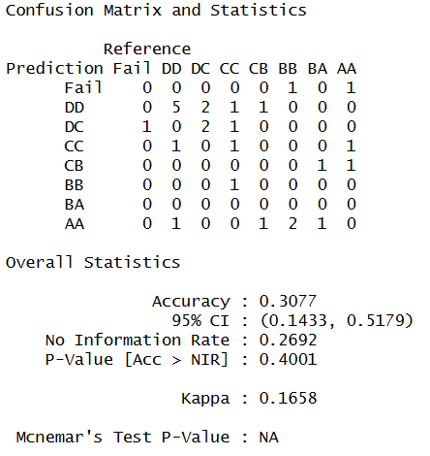
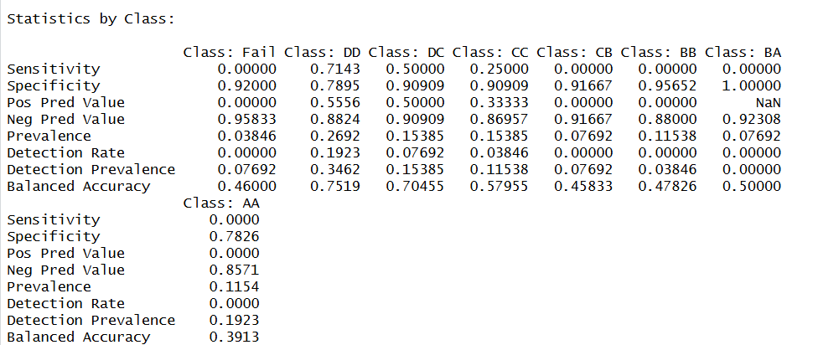

Figure 2 & 3: Output from Random Forest
The random forest classifier achieved an overall accuracy of approximately 31%, slightly above the no-information rate but with low agreement beyond chance (Kappa = 0.17). Performance was strongest for mid-range grades such as DD and DC, while extreme outcomes (Fail and AA) were poorly predicted due to class imbalance. These results suggest that socioeconomic and educational background variables alone don’t provide enough to predict exact grade classification, highlighting the importance of behavioral and academic engagement factors. One thing to improve this model is to add behavioral variables such as their attendance to class, weekly study hours, or note taking. However, I think that those variables are very subjective while the ones analyzed here a little more concrete.
Another model I ran was a linear regression model of grades against salary, scholarship type, and high school type. This would directly show the direction and magnitude of the variable’s effects. I think it would also be helpful because the letter grades are ordered so it can display the direct impact.
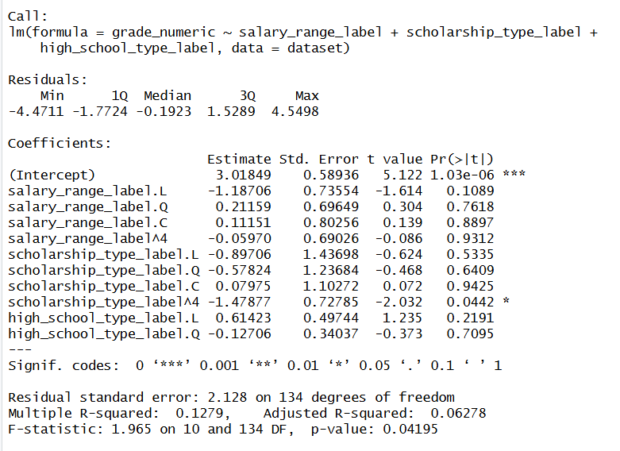
Figure 4: Linear Regression Output
The R² value shows us that these factors cover about 13% of the variation. This makes sense because the rest of the dataset shows us that many other factors impact student’s education. However, the model is statistically significant with a p-value of 0.04195. Thus, as a group, these predictors are better than chance. The intercept at ~3.02 represents the average grade level which is around a CC/CB. This is consistent with typical grading conventions with C being the average. On the other hand, the factors are ordered, we have to analyze the components. Salary does not seem to have a significant linear trend with the p-values being greater than 0.05. Similarly, high-school type does not significantly predict grades. Scholarship type displays the opposite with scholarship_type_label.4 having a p-value of 0.04 and thus being significant. Higher scholarship tiers are associated with higher academic performance. The random forest results are also matched here as the residual error is around 2 grade levels confirming that predicting exact grades is difficult.
Lastly, I used K-Means clustering to discover groups between the students based on the socioeconomic and educational characteristics. I plotted two different types of graph. Figure 5 was plotted using PCA to make the multidimensional factors into two dimensions. Figure 6 is more interpretation focused and shows the meaning behind the clusters.
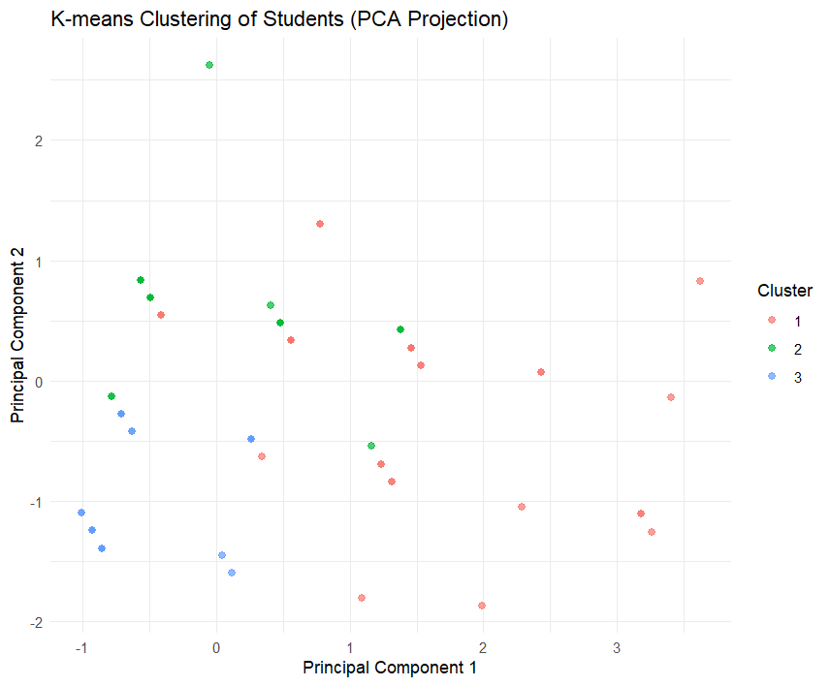
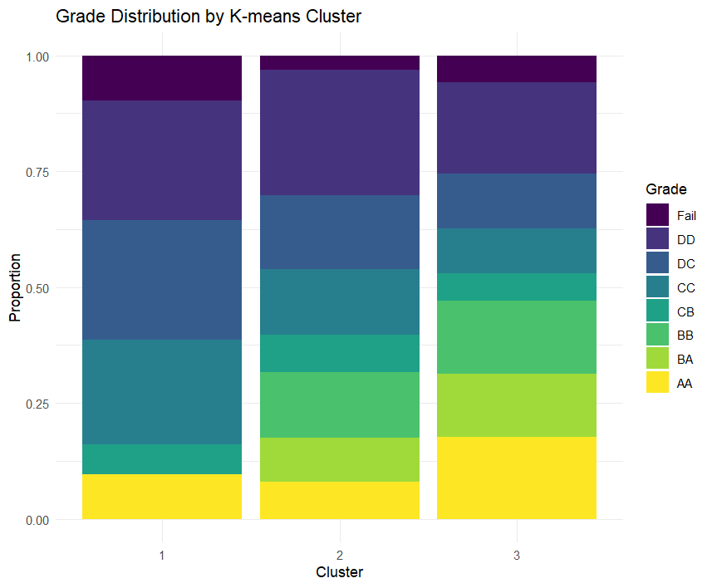
Figure 5: PCA Cluster Plot Figure 6: Grade Distribution by Grade

These two plots serve different purposes. Figure 5 tries to see if there separable groups in the data. The plot shows moderate separation between clusters in the reduced feature space, indicating meaningful grouping based on socioeconomic and educational variables. However, Figure 6 proves to be more useful because it answers the question of if the clusters actually mean something in terms of grades. It directly links unsupervised clusters to grades and shows clear performance differences between clusters. Cluster 1 is dominated by lower grades – DD/DC/CC while cluster 2 is mixed with average performers. Cluster 3 has the highest proportions of BA/AA students. Thus, the clustering is academically meaningful, but not mathematically.

Decisions
From these results we can conclude that there are certain socio-economic factors that do affect student performance in courses. Namely scholarship type was important in recognizing performance. All the models support this idea. I think this is because good grades typically indicate the likelihood of maintaining the scholarship. Although these factors played a prominent role, they didn’t encompass the entire student. These features are more or less out of the student’s control. In many cases, students who are able to afford more affluent options, tend to have more access to resources. Thus, this study shows that there is consequence to this result, highlighting the importance of behavioral and academic engagement factors. I think these findings can help prove that analyzing each factor would be beneficial to get a better picture. Using these variables has allowed me to explore factors from a broader scale.

